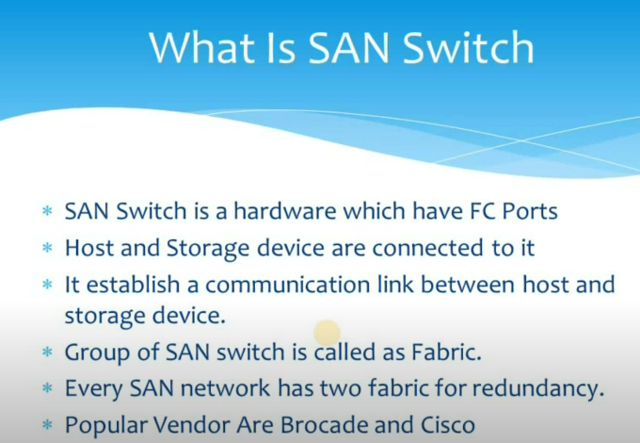
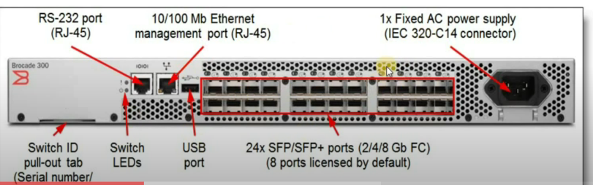
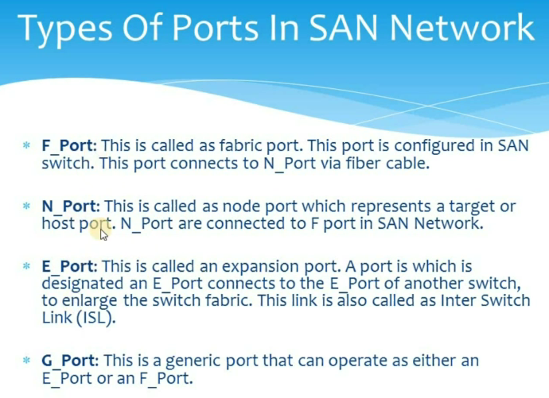
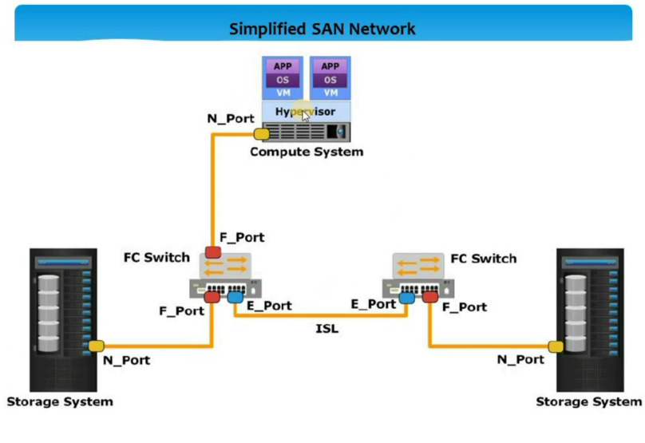

2.RITM3025309
Server: inlocapp3.in.tntms.com
Destination: D:\Restore\RITM3025309
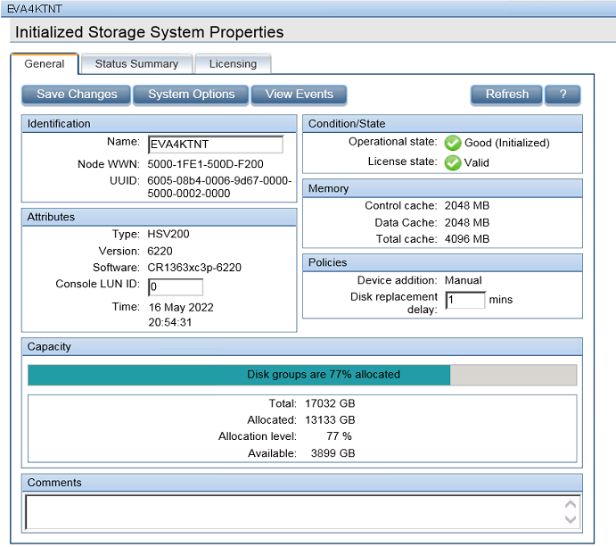

S.No | vCenter Name
1 | auenvcsa200.au.express.tnt
2 | aumavcsa200.au.express.tnt
3 | belggvc1.tntad.fedex.com
4 | belggvc2.tntad.fedex.com
5 | cncdcvc03.cx.tnt.com
6 | deftvce001.de.express.tnt
7 | DKBLLVPS1.dk.express.tnt
8 | gbaheitvca03.ics.express.tnt
9 | gbahepodvc01.tntad.fedex.com
10 | gbahepodvc04.ics.express.tnt
11 | gbahevca03.ics.express.tnt
12 | itmil3vca03.it.express.tnt
13 | jptyvce101.jp.tntms.com
14 | sgs1vca201.sg.express.tnt
15 | ukwyvca201.tntad.fedex.com
16 | vcathedmzvc01.tntad.fedex.com

